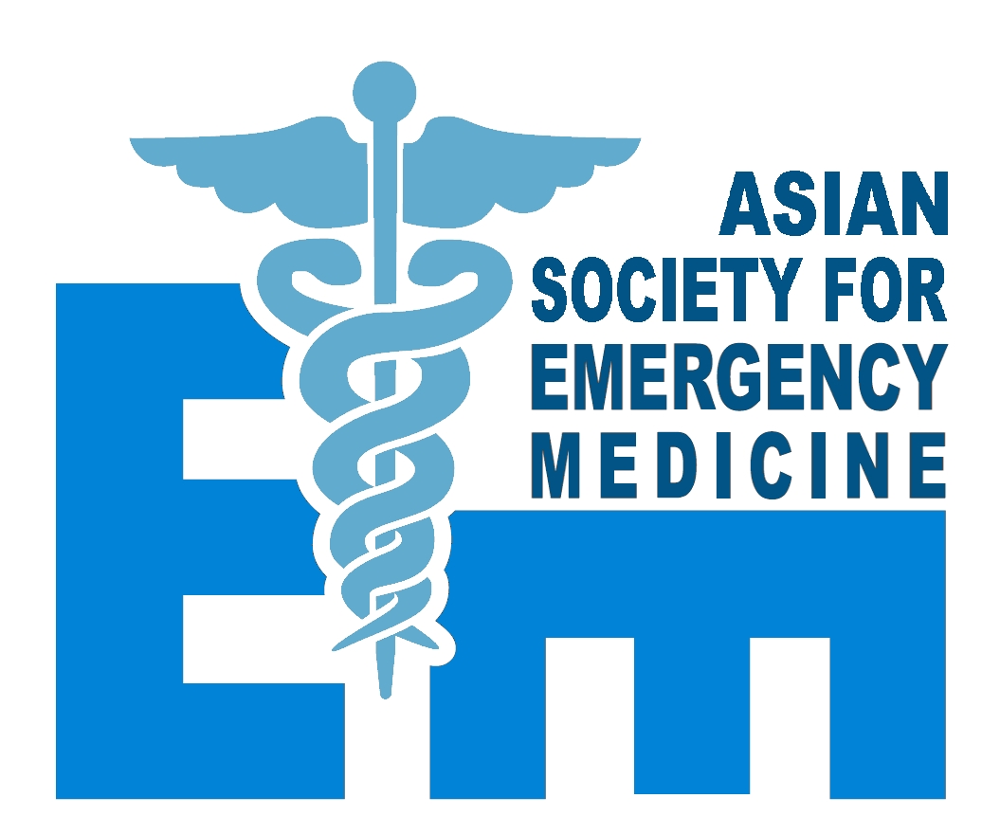
Asian Society for Emergency Medicine (ASEM)

SOCIETY MEMBER APPLICATION FORM

Official Name of Organisation/Society : _______________________________________________
Mailing Address : ________________________________________________________________
________________________________________________________________
________________________________________________________________
Email Address : _________________________________________________________________
Contact Number : ________________________________________________________________
Fax Number : _________________________________________________________________

- Organisation date of establishment. Please attach a brief history __________________

- Does your society have a written charter / by-laws reflecting its missions, goals and objectives? If yes, please attach a copy in English

- How many active members does your organization currently have? _________________________

- Does your organisation have non-physician members? __________________________________

If yes, please describe : ___________________________________________________________

- Does a recognised physician training program in emergency medicine exist in your country? Are such training programs available at more than one hospital or location? If yes, please attach brief training program.

- Contact details of the individual who will represent your country if this application is accepted

Title and Name : _____________________________________________________________________

Mailing Address : ____________________________________________________________________

Email Address : ______________________________________________________________________

Phone Number : __________________________ Fax Number : __________________________

Applicant’s Signature : _____________________ Date : ________________________________

Charter / By-Laws of Organisation/Society enclosed Emergency Physician Training Program

History of Organisation/Society enclosed

Please return the completed Application Form, along with supporting documentation to :

Secretary,
Asian Society for Emergency Medicine
Email: asiansociety@gmail.com

